

Semester Two Examination, 2021

Question/Answer booklet

MATHEMATICS  
SPECIALIST  
UNITS 1&2

**SOLUTIONS**

Section One:  
Calculator-free

|  |  |  |  |  |  |  |  |  |  |  |
| --- | --- | --- | --- | --- | --- | --- | --- | --- | --- | --- |
| WA student number: In figures |  |  |  |  |  |  |  |  |  |  |

In words

Your name

|  |  |
| --- | --- |
| Number of additional answer booklets used (if applicable): |  |

## Time allowed for this section

Reading time before commencing work: five minutes

Working time: fifty minutes

## Materials required/recommended for this section

***To be provided by the supervisor***

This Question/Answer booklet

Formula sheet

***To be provided by the candidate***

Standard items: pens (blue/black preferred), pencils (including coloured), sharpener,  
correction fluid/tape, eraser, ruler, highlighters

Special items: nil

## Important note to candidates

No other items may be taken into the examination room. It is **your** responsibility to ensure that you do not have any unauthorised material. If you have any unauthorised material with you, hand it to the supervisor **before** reading any further.

## Structure of this paper

|  |  |  |  |  |  |
| --- | --- | --- | --- | --- | --- |
| Section | Number of questions available | Number of questions to be answered | Working time (minutes) | Marks available | Percentage of examination |
| Section One: Calculator-free | 8 | 8 | 50 | 50 | 35 |
| Section Two: Calculator-assumed | 13 | 13 | 100 | 92 | 65 |
|  | | |  | **Total** | 100 |

## Instructions to candidates

1. The rules for the conduct of examinations are detailed in the school handbook. Sitting this examination implies that you agree to abide by these rules.

2. Write your answers in this Question/Answer booklet preferably using a blue/black pen.  
Do not use erasable or gel pens.

3. You must be careful to confine your answers to the specific question asked and to follow any instructions that are specific to a particular question.

4. Show all your working clearly. Your working should be in sufficient detail to allow your answers to be checked readily and for marks to be awarded for reasoning. Incorrect answers given without supporting reasoning cannot be allocated any marks. For any question or part question worth more than two marks, valid working or justification is required to receive full marks. If you repeat any question, ensure that you cancel the answer you do not wish to have marked.

5. It is recommended that you do not use pencil, except in diagrams.

6. Supplementary pages for planning/continuing your answers to questions are provided at the end of this Question/Answer booklet. If you use these pages to continue an answer, indicate at the original answer where the answer is continued, i.e. give the page number.

7. The Formula sheet is not to be handed in with your Question/Answer booklet.

Section One: Calculator-free 35% (50 Marks)

This section has**eight** questions. Answer **all** questions. Write your answers in the spaces provided.

Working time: 50 minutes.

Question 1 (5 marks)

Let matrix $A=\left[\begin{matrix}-2 & 0 \\ 3 & 1\end{matrix}\right]$ and matrix $B=\left[\begin{matrix}2k-1 & 1 \\ 2 & k+1\end{matrix}\right]$, where $k$ is a constant.

(a) When $k=-1$, determine

(i) $AB$. (1 mark)

|  |
| --- |
| Solution |
| $$AB=\left[\begin{matrix}-2 & 0 \\ 3 & 1\end{matrix}\right]×\left[\begin{matrix}-3 & 1 \\ 2 & 0\end{matrix}\right] \\ =\left[\begin{matrix}6 & -2 \\ -7 & 3\end{matrix}\right]$$ |
| Specific behaviours |
| ü correct product |

(ii) $3A-2B$. (2 marks)

|  |
| --- |
| Solution |
| $$3A-2B=\left[\begin{matrix}-6 & 0 \\ 9 & 3\end{matrix}\right]-\left[\begin{matrix}-6 & 2 \\ 4 & 0\end{matrix}\right] \\ =\left[\begin{matrix}0 & -2 \\ 5 & 3\end{matrix}\right]$$ |
| Specific behaviours |
| ✓ correct scalar multiples  ü correct difference |

(b) Determine the value(s) of $k$ if matrix $B$ is singular. (2 marks)

|  |
| --- |
| Solution |
| $$\det{B}=0 \\ \left(2k-1\right)\left(k+1\right)-2=0 \\ 2k^{2}+k-3=0 \\ \left(2k+3\right)\left(k-1\right)=0 \\ k=1, k=-\frac{3}{2}$$ |
| Specific behaviours |
| ✓ equates expression for determinant to zero  ü correct values of $k$ |

Question 2 (6 marks)

(a) Sketch the graph of $y=\sec\left(\begin{matrix}x \\ \overline{2}\end{matrix}\right)$ on the axes below for $0≤x≤4π$. (3 marks)

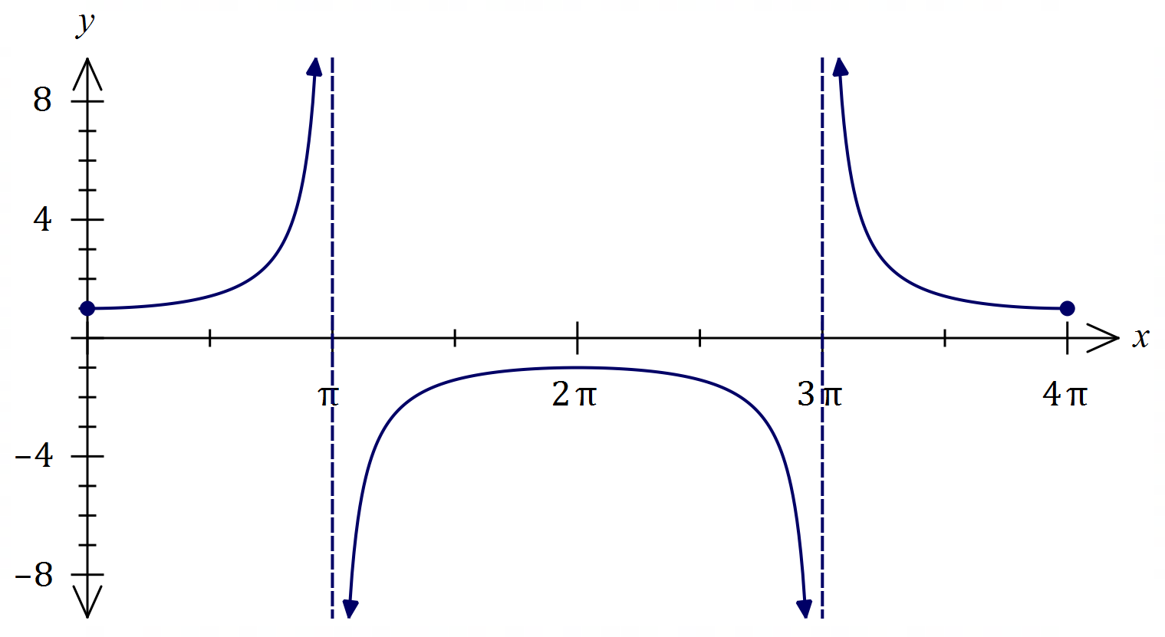

|  |
| --- |
| Solution |
| See graph |
| Specific behaviours |
| ✓ asymptotes  ü $y$-intercept, max  ü correct curvature |

(b) Prove the identity $\operatorname{cosec}{2A}-\cot{2A}=\tan{A}$. (3 marks)

|  |
| --- |
| Solution |
| $$LHS=\operatorname{cosec}{2A}-\cot{2A} \\ =\frac{1}{\sin{2A}}-\frac{\cos{2A}}{\sin{2A}} \\ =\frac{1-\cos{2A}}{\sin{2A}} \\ =\frac{2\sin^{2}{A}}{2\sin{A}\cos{A}} \\ =\frac{\sin{A}}{\cos{A}} \\ =\tan{A} \\ =RHS$$ |
| Specific behaviours |
| ✓ converts between reciprocal and basic trig functions  ü writes as single fraction  ü uses double angle identities and simplifies |

Question 3 (6 marks)

Let $z_{1}=\sqrt{5}+3i$ and $z_{2}=\sqrt{5}-i$. Determine each of the following in the form $a+bi$.

(a) $2z_{1}-z_{2}$. (1 mark)

|  |
| --- |
| Solution |
| $$2\sqrt{5}+6i-\left(\sqrt{5}-i\right)=\sqrt{5}+7i$$ |
| Specific behaviours |
| ✓ correct result |

(b) $i{\overline{z}}_{1}$. (1 mark)

|  |
| --- |
| Solution |
| $$i\left(\sqrt{5}-3i\right)=3+\sqrt{5}i$$ |
| Specific behaviours |
| ü correct result |

(c) $z_{1}×z_{2}$. (2 marks)

|  |
| --- |
| Solution |
| $$\left(\sqrt{5}+3i\right)\left(\sqrt{5}-i\right)=5+3\sqrt{5}i-\sqrt{5}i+3 \\ =8+2\sqrt{5}i$$ |
| Specific behaviours |
| ✓ correctly expands  ü correct result |

(d) $z_{1}÷z_{2}$. (2 marks)

|  |
| --- |
| Solution |
| $$\frac{\sqrt{5}+3i}{\sqrt{5}-i}×\frac{\sqrt{5}+i}{\sqrt{5}+i}=\frac{2+4\sqrt{5}i}{6} \\ =\frac{1}{3}+\frac{2\sqrt{5}}{3}i$$ |
| Specific behaviours |
| ✓ uses conjugate correctly  ü correct result |

Question 4 (6 marks)

(a) Determine the value(s) of the constant $t$ given that $\left[\begin{matrix}-2 & 4 \\ t & 8\end{matrix}\right]\left[\begin{matrix}t \\ t\end{matrix}\right]=\left[\begin{matrix}2t \\ 33\end{matrix}\right]$. (2 marks)

|  |
| --- |
| Solution |
| $$t^{2}+8t=33 \\ t^{2}+8t-33=0 \\ \left(t+11\right)\left(t-3\right)=0 \\ t=-11, t=3$$ |
| Specific behaviours |
| ✓ forms quadratic  ü correct values |

(b) Determine $A^{-1}$ when $A=\left[\begin{matrix}7 & 3 \\ -2 & 2\end{matrix}\right]$. (2 marks)

|  |
| --- |
| Solution |
| $${\left[\begin{matrix}7 & 3 \\ -2 & 2\end{matrix}\right]}^{-1}=\frac{1}{20}\left[\begin{matrix}2 & -3 \\ 2 & 7\end{matrix}\right]$$ |
| Specific behaviours |
| ✓ indicates determinant  ü correct inverse |

(c) Show use of matrix methods to solve the following system of linear equations:

$$7x+3y-25=0 \\ 2y-2x+10=0$$

(2 marks)

|  |
| --- |
| Solution |
| $$\left[\begin{matrix}7 & 3 \\ -2 & 2\end{matrix}\right]\left[\begin{matrix}x \\ y\end{matrix}\right]=\left[\begin{matrix}25 \\ -10\end{matrix}\right]$$ $$\left[\begin{matrix}x \\ y\end{matrix}\right]=\frac{1}{20}\left[\begin{matrix}2 & -3 \\ 2 & 7\end{matrix}\right]\left[\begin{matrix}25 \\ -10\end{matrix}\right] \\ =\left[\begin{matrix}4 \\ -1\end{matrix}\right]$$ |
| Specific behaviours |
| ✓ writes as matrix equation  ü shows use of inverse and obtains correct solution |

Question 5 (6 marks)

(a) Using a product identity, or otherwise, evaluate $\sin\left(\begin{matrix}5π \\ \overline{12}\end{matrix}\right)+\sin\left(\begin{matrix}π \\ \overline{12}\end{matrix}\right)$. (3 marks)

|  |
| --- |
| Solution |
| $$\sin\left(\frac{5π}{12}\right)+\sin\left(\frac{π}{12}\right)=\sin\left(\frac{3π+2π}{12}\right)+\sin\left(\frac{3π-2π}{12}\right) \\ =2\sin\left(\frac{3π}{12}\right)\cos\left(\frac{2π}{12}\right) \\ =2×\frac{\sqrt{2}}{2}×\frac{\sqrt{3}}{2} \\ =\frac{\sqrt{6}}{2}$$ |
| Specific behaviours |
| ✓ indicates appropriate sum and difference  ü uses identity  ü evaluates |

(b) Solve the equation $2\sin^{2}{2x}=3\cos{2x}, 0≤x≤2π$. (3 marks)

|  |
| --- |
| Solution |
| $$2\left(1-\cos^{2}{2x}\right)-3\cos{2x}=0 \\ 2\cos^{2}{2x}+3\cos{2x}-2=0 \\ \left(2\cos{2x}-1\right)\left(\cos{2x}+2\right)=0 \\ \cos{2x}=\frac{1}{2} \\ 2x=\frac{π}{3},\frac{5π}{3},\frac{7π}{3},\frac{11π}{3} \\ x=\frac{π}{6}, \frac{5π}{6}, \frac{7π}{6}, \frac{11π}{6}$$ |
| Specific behaviours |
| ✓ uses Pythagorean identity to form quadratic  ü factors quadratic and indicates one solution  ü all correct solutions |

Question 6 (7 marks)

(a) Determine all complex solutions to the equation $z^{2}-10z+27=0$. (2 marks)

|  |
| --- |
| Solution |
| $${\left(z-5\right)}^{2}=25-27 \\ {\left(z-5\right)}^{2}=2i^{2} \\ z=5±\sqrt{2}i$$ |
| Specific behaviours |
| ✓ completes square  ü both correct solutions |

(b) $z_{1}=-4-i$ is a solution to $f\left(z\right)=0$, where $f(z)$ is a real quadratic polynomial.

(i) State $z_{2}$, another solution to $f\left(z\right)=0$. (1 mark)

|  |
| --- |
| Solution |
| $$z=-4+i$$ |
| Specific behaviours |
| ✓ correct complex number |

(ii) Let $z_{3}=z_{2}-z_{1}$. Plot and label $z_{1}, z_{2}$ and $z_{3}$ in the complex plane below. (2 marks)

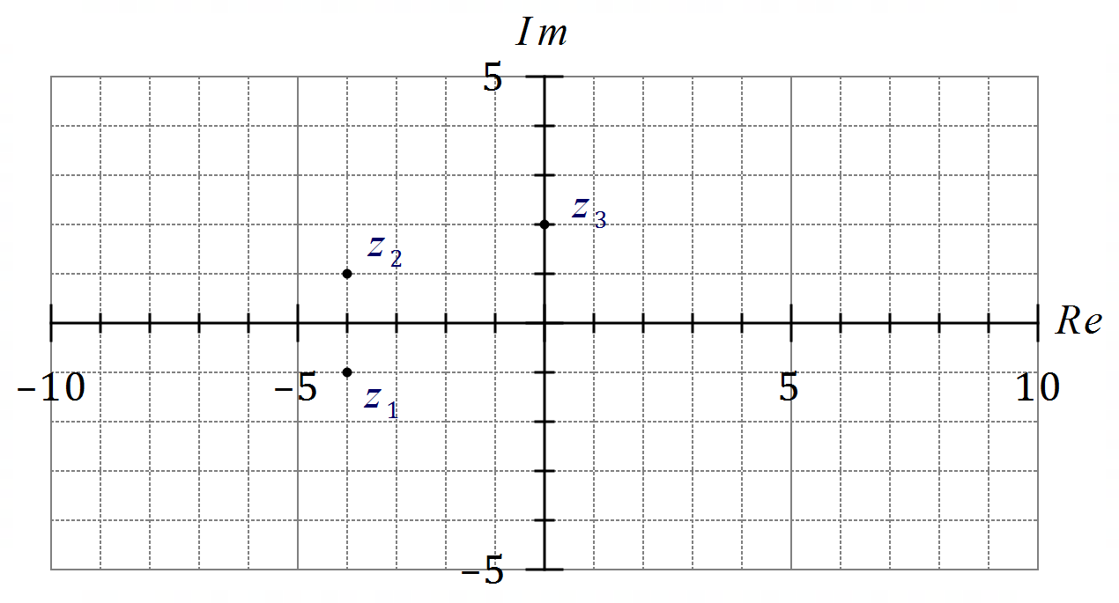

|  |
| --- |
| Solution |
| See graph |
| Specific behaviours |
| ✓ sketches roots as conjugate pair  ü correctly locates $z_{3}$ |

(iii) Determine $f(z)$, given that the coefficient of its $z^{2}$ term is $1$. (2 marks)

|  |
| --- |
| Solution |
| Let $f\left(z\right)=z^{2}+bz+c$.  Then $b=-2\left(-4\right)=8$ and $c=4^{2}+1^{2}=17$. $$f\left(z\right)=z^{2}+8z+17$$ |
| Specific behaviours |
| ✓ shows sum and product of roots (or product of factors)  ü correct equation |

Question 7 (6 marks)

Use mathematical induction to prove that $2^{5n}-5^{n}$ is divisible by $9$ for all integers $n≥1$.

|  |
| --- |
| Solution |
| Let $f\left(n\right)=2^{5n}-5^{n}$.  When $n=1$ then $$f(1)=32-5 \\ =27 \\ =3×9 \text{which is divisible by} 9$$ Assume true for $n=k$ so that $2^{5k}-5^{k}=9I$ for some integer $I$.  When $n=k+1$ then $$f\left(k+1\right)=2^{5k+5}-5^{k+1} \\ =2^{5}∙2^{5k}-5∙5^{k} \\ =32\left(9I+5^{k}\right)-5∙5^{k} \text{(using assumption)} \\ =32\left(9I\right)+27\left(5^{k}\right) \\ =9\left(32I+3\left(5^{k}\right)\right) \text{which is divisible by} 9$$ Hence $f(n)$ is divisible by $9$ for $n=k+1$ and as demonstrated divisible for $n=1$ then will be divisible for all $n≥1$. |
| Specific behaviours |
| ✓ demonstrates true for $n=1$ ü makes assumption for $n=k$ ü expression for $f(k+1)$ ü uses assumption to replace $2^{5k}$ ü factors out $9$ from $f(k+1)$ ü concluding statement |

Question 8 (8 marks)

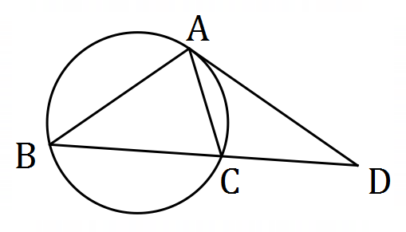(a) Points $A, B$ and $C$ lie on a circle.  
  
The tangent to the circle at $A$ intersects secant $BC$ at point $D$.

Prove that $AD^{2}=BD×CD$. (4 marks)

|  |
| --- |
| Solution |
| First prove that $ΔADC\sim ΔBDA$: $$∠ADC=∠BDA (\text{common}) \\ ∠DAC=∠DBA (\text{angles in opposite segments})$$ Hence $ΔADC\sim ΔBDA$ as two pairs of congruent angles.  Using ratios of corresponding sides, $\begin{matrix}AD \\ \overline{BD}\end{matrix}=\begin{matrix}CD \\ \overline{AD}\end{matrix}⇒AD^{2}=BD×CD$. |
| Specific behaviours |
| ✓ shows congruency of one pair of angles, with reasoning  ✓ shows congruency of second pair of angles, with reasoning  ü establishes similarity, with reasoning  ü completes proof using ratio of sides |

(b) Two unequal circles intersect at $P$ and $Q$. A common tangent touches one circle at $R$ and the other circle at $S$. $PQ$ produced intersects $RS$ at $X$. Prove that $X$ bisects $RS$. (4 marks)

|  |
| --- |
| Solution |
| Let $PQ$ and $RS$ intersect at $X$.  In smaller circle, $RX^{2}=XQ×XP$ (tangent secant theorem)  In larger circle, ${SX}^{2}=XQ×XP$ (tangent secant theorem)  Hence $RX^{2}=SX^{2}⇒RX=SX$ and so $PQ$ produced bisects $RS$. |
| Specific behaviours |
| ✓ labelled diagram  ü uses tangent-secant theorem in one circle  ü uses tangent-secant theorem in the other circle  ü concludes proof |

Supplementary page

Question number: _________

© 2021 WA Exam Papers. Kennedy Baptist College has a non-exclusive licence to copy and communicate this document for non-commercial, educational use within the school. No other copying, communication or use is permitted without the express written permission of WA Exam Papers. SN245-181-3.